**Assignment No : 12**

**Problem Statement :Deploy and run the project in AWS without using the port**

1 . Create a new repository (Ex-repo1) in Github & upload the project files. Click ‘Code’ & copy the https link for later use .

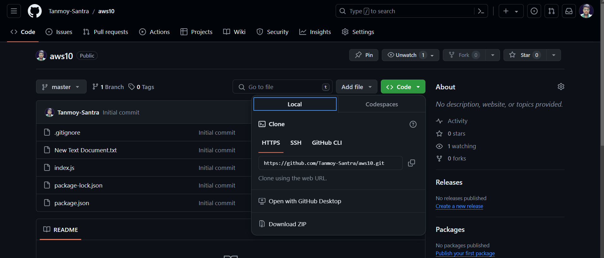

2. Log in to AWS, goto EC2. Click on ‘Security Groups’ & then click ‘Create security Group’.

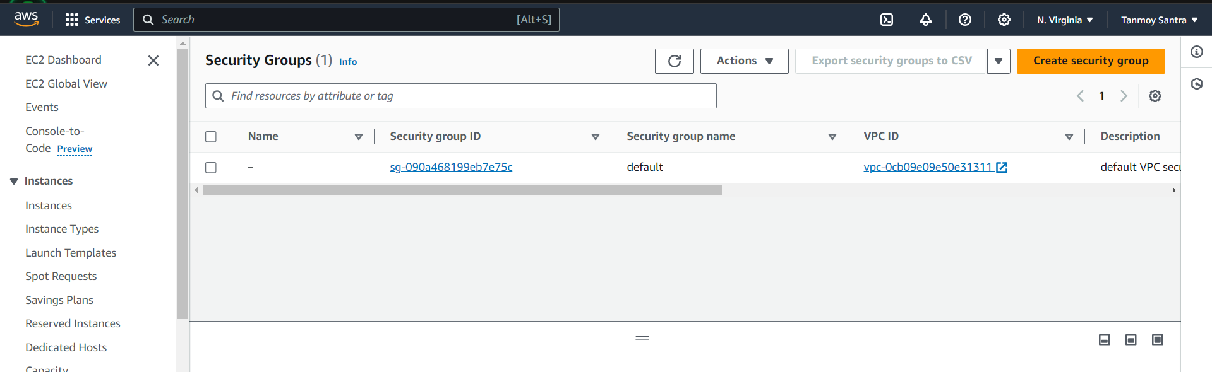

3. Give a group name & description.

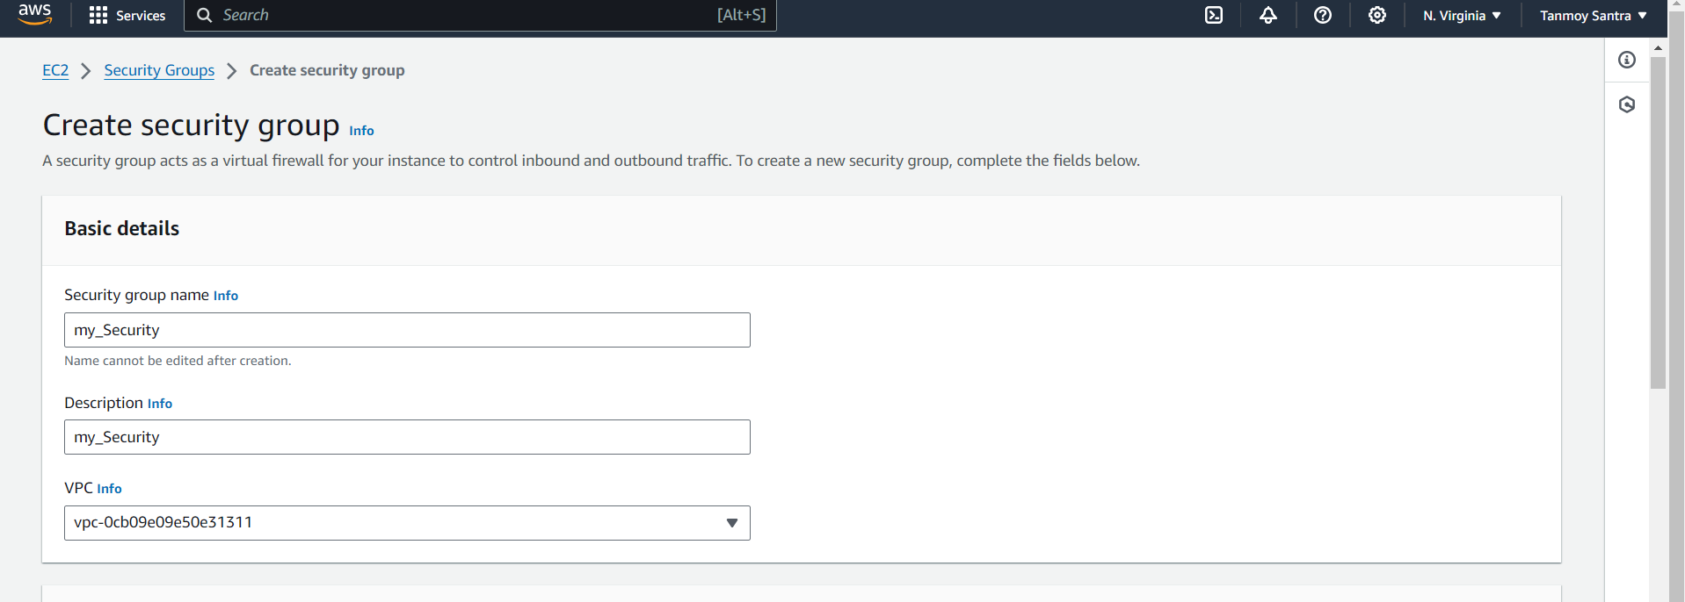

4. In the ‘Inbound rules’ section click on ‘Add rule’. Give port range ‘4000’ and select ‘0.0.0.0/0’ for the 'Custom TCP'.  
Click on 'Add rule' & add 3 rules of type SSH, HTTP and HTTPS.Select ‘0.0.0.0/0’ for all & click on Create security 'group

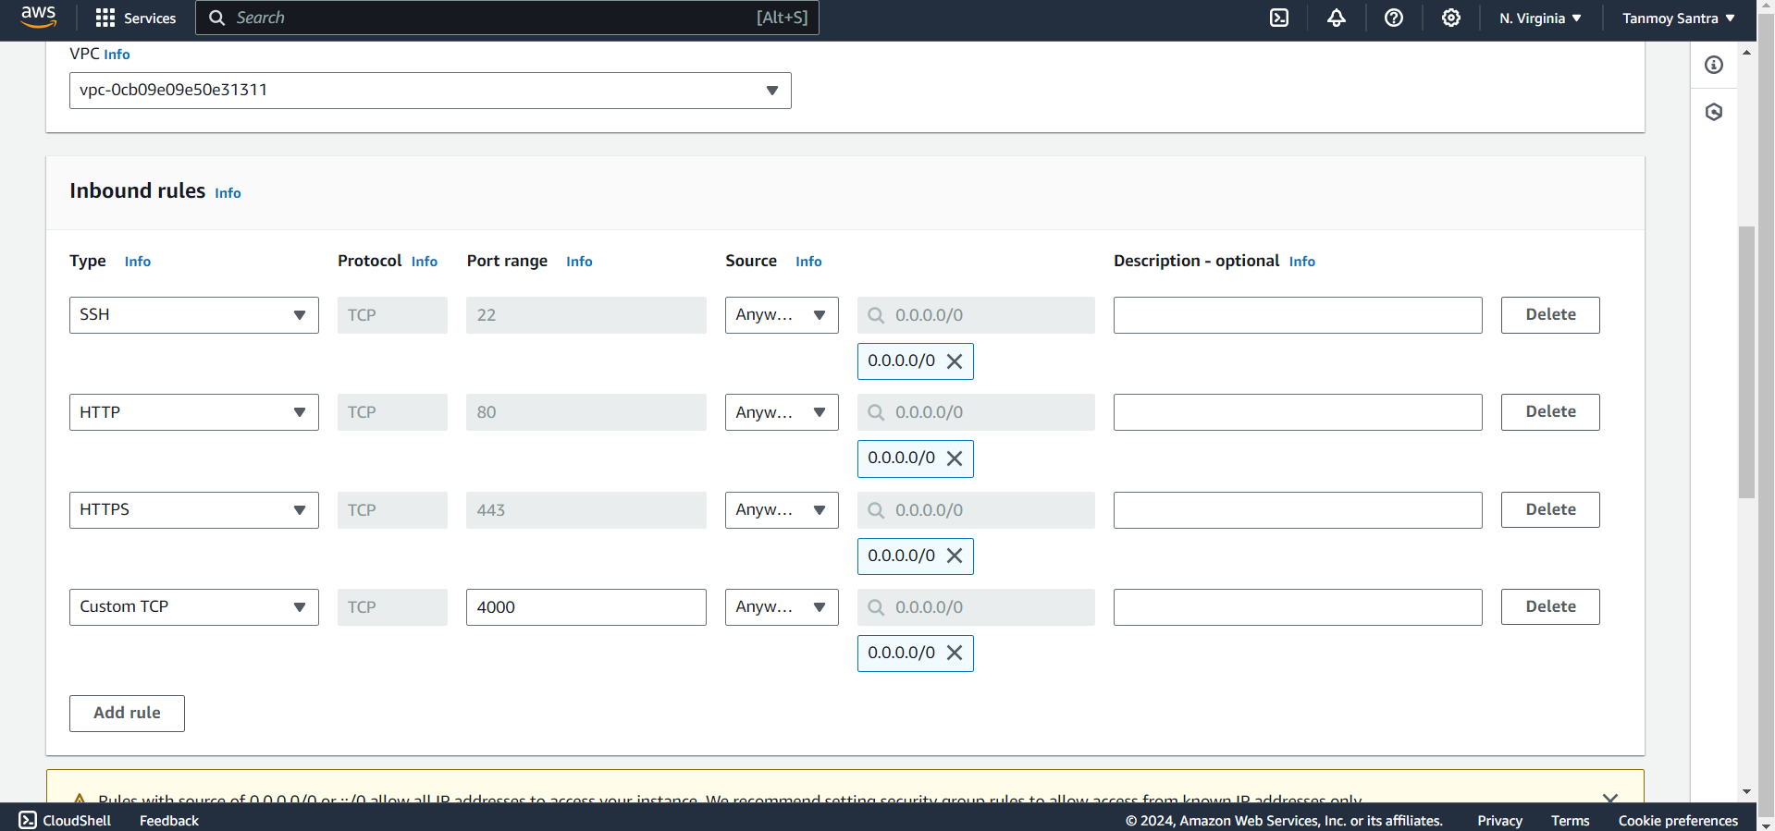

5. Goto EC2 dashboard & click ‘Launch Instance’. Give server name. (Ex-arnabkoley) Select ‘Ubuntu’ as ‘Application and OS image’. Select an existing key pair or generate a new key pair. (download the .pem file) Click 'Existing security group' group and select the newly created security group.Click Launch Instance.

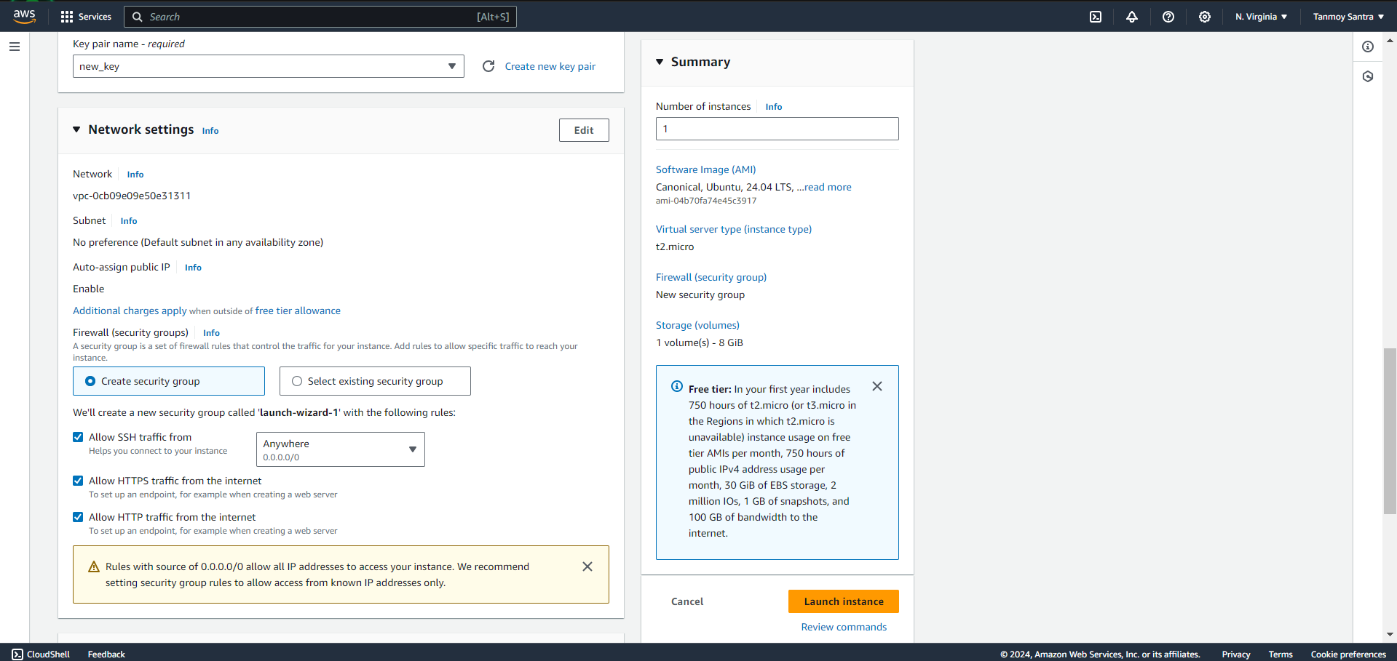

6. G to 'Instances' and click on the instance id of the newly created instance. Copy the public IPv4 address

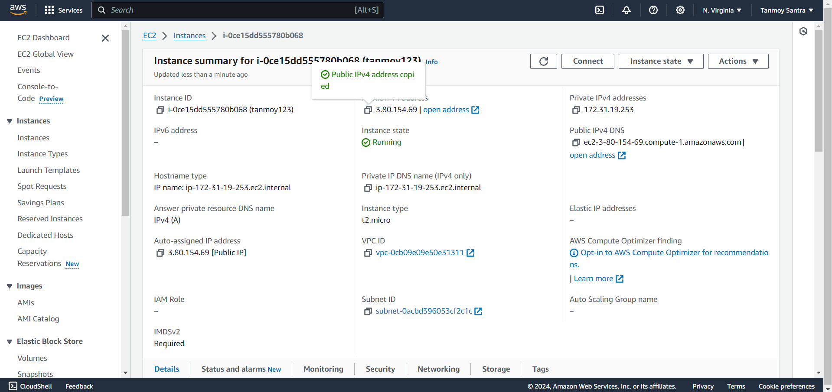

7. Open Bitvise SSH, goto ‘Client key manager’ and import the downloaded .pem file.Give the copied ipv4 address in ‘Host’.Give Username ‘ubuntu’, select initial method ‘publickey’ & Client key ‘Global 1’.Click on ‘log in’.

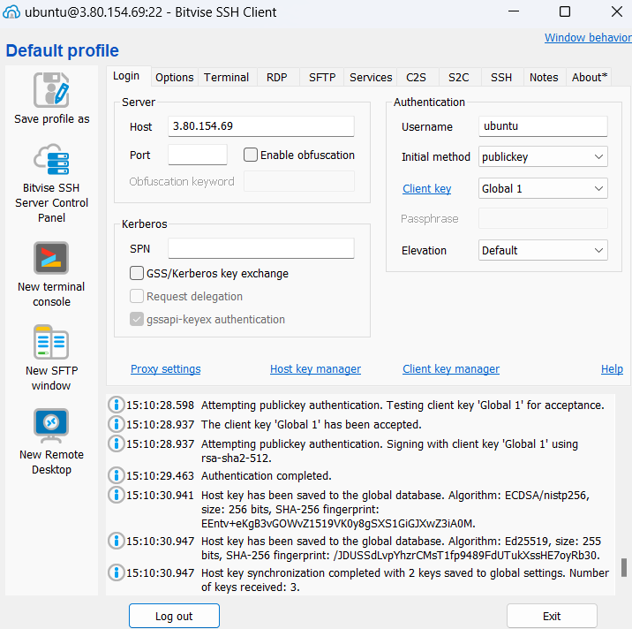

8. Click ‘New terminal console’ & run the following commands:  
 sudo apt-get update (To install the latest packages)   
sudo apt-get upgrade (To update all installed packages)



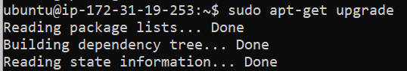

sudo apt-get install nginx (To install nginx web server)

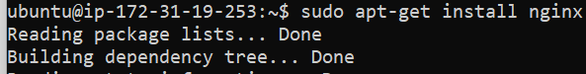

curl -SL https://deb.nodesource.com/setup_16.x | sudo -E bash –sudo apt install nodejs (To install nodejs)

  
git clone https://github.com/Tanmoy-Santra/ass10.git (To clone the project folder)

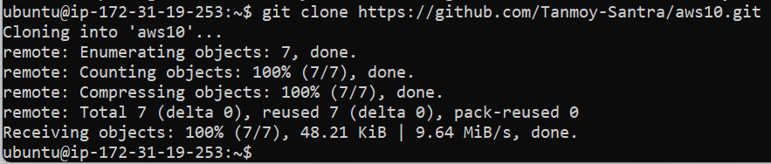

cd ass10 (Goto project folder)  
npm install (To install all node modules & dependencies)

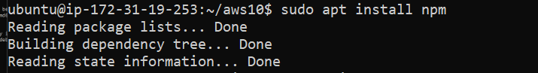



9. Run the following commands:  
cd /  
pwd  
cd etc/nginx/sites-available/

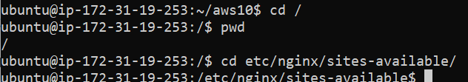  
sudo nano default

10. A new window will be opened. There at first go to location area and

comment all codes and the write:

10)

location/{  
proxy_pass http://localhost:4000;  
proxy_http_version 1.1;  
proxy_set_header Upgrade $http_upgrade;  
proxy_set_header Connection ‘upgrade’;  
proxy_set_header Host $host;  
proxy_cache_bypass $http_upgrade;  
}  
After that click ctrl+x, then y, then click enter.

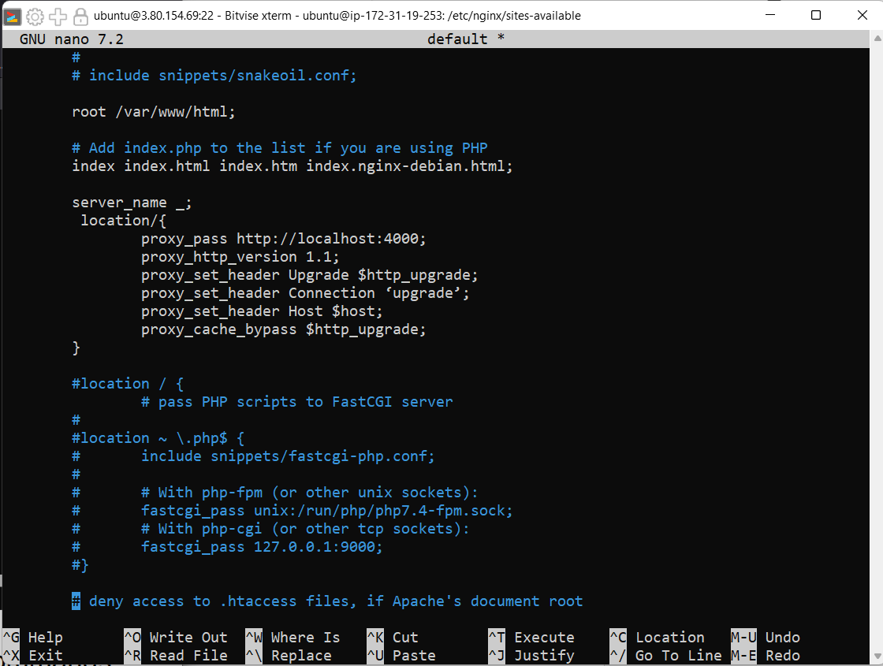

11. Open a new terminal and run the following commands:

cd repo name (Open the project folder)

sudo systemctl restart nginx (Restart the nginx server)

node index.js (Start the server)





12 . Paste the previously copied pv4 address in the browser without port.

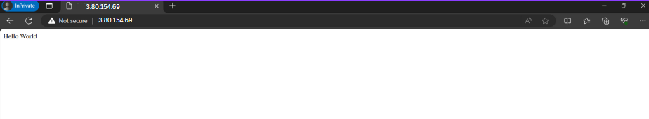

13. Deployment and run of a project in AWS without using the port is successfully

completed.